Short Questions:

- Why is multiplexing so cost-effective?
- How is interference avoided by using frequency division multiplexing?
- What is echo cancellation?
- Define upstream and downstream with respect to subscriber lines.
- Explain how synchronous time division multiplexing (TDM) works.
- Why is a statistical time division multiplexor more efficient than a synchronous time division multiplexor?
- Using Table 1 as a guide, indicate the major difference between North American and international TDM carrier standards.
Table 1: North American and International TDM Carrier Standards
North American |  |  |  | International (ITU-T)
Designation | Number of Voice Channels | Data Reate (Mbps) |  | Level | Number of Voice Channels | Data Reate (Mbps)
DS-1 | 24 | 1,544 |  | 1 | 30 | 2,048
DS-1C | 48 | 3,152 |  | 2 | 120 | 8,448
DS-2 | 96 | 6,312 |  | 3 | 480 | 34,368
DS-3 | 672 | 44,736 |  | 4 | 1920 | 139,264
DS-4 | 4032 | 274,176 |  | 5 | 7680 | 565,148

- Using Figure 1 as a guide, indicate the relationship between buffer size and line utilisation.

Problems:

- The information in four analog signals is to be multiplexed and transmitted over a telephone line that has 400- to 3100Hz-bandpass. Each of the analog baseband signals is bandlimited to 500Hz. Design a communications system (block diagram) that will allow the transmission of these four sources over the telephone channel using
  - Frequency division multiplexing with SSB (single sideband) subcarriers
  - Time division multiplexing using PCM: assume 4-bit samples
Show the block diagrams of the complete system, including the transmission, channel, and reception portions. Include the bandwidth of the signals at the various points in the system.
- To paraphrase Lincoln:...all of the channel some of the time, some of the channel all of the time.... Refer to Figure 2 and relate the preceding to the figure.
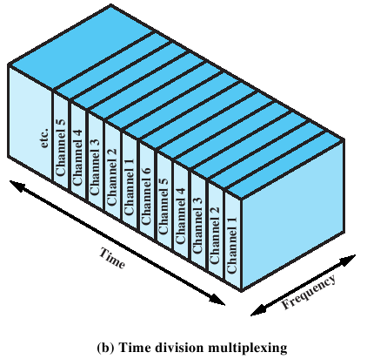
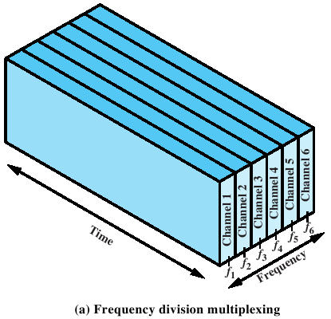Figure 1: FDM and TDM
- Explain in terms of data link control and physical layer concepts how error and flow control are accomplished in synchronous time division multiplexing.
- One of the 193 bits in the DS-1 transmission format is used for frame synchronisation. Explain its use.
- In the DS-1 format, what is control signal data rate for each voice channel?
- Twenty-four voice channels are to be multiplexed and transmitted over twisted pair. What is the bandwidth required for FDM? Assuming a bandwidth efficiency (ratio of data rate to transmission bandwidth, as explained in Chapter 5) of 1 bps/Hz, what is the bandwidth required for TDM using PCM?
- Find the number of the following devices that could be accommodated by a T1-type TDM line if 1% of the T1 line capacity is reserved for synchronisation purposes.
  - 110-bps teleprinter terminals
  - 300-bps computer terminals
  - 1200-bps computer terminals
  - 9600-bps computer ports
  - 64-kbps PCM voice-frequency lines
How would these numbers change if each of the sources were transmitting an average of 10% of the time and the statistical multiplexer was used?
- Assume that you are to design a TDM carrier, say DS-489, to support 30 voice channels using 6-bit samples and a structure similar to DS-1. Determine the required bit rate.
Answers:

Short Questions

- Multiplexing is cost-effective because the higher the data rate, the more cost-effective the transmission facility.
- Interference is avoided under frequency division multiplexing by the use of guard bands, which are unused portions of the frequency spectrum between subchannels.
- Echo cancellation is a signal processing technique that allows transmission of digital signals in both directions on a single transmission line simultaneously. In essence, a transmitter must subtract the echo of its own transmission from the incoming signal to recover the signal sent by the other side.
- Downstream: from the carrier’s central office to the customer’s site; upstream: from customer to carrier.
- A synchronous time division multiplexer interleaves bits from each signal and takes turns transmitting bits from each of the signals in a round-robin fashion.
- A statistical time division multiplexer is more efficient than a synchronous time division multiplexer because it allocates time slots dynamically on demand and does not dedicate channel capacity to inactive low speed lines.
- The basic difference between North American and international TDM carrier standards is that the North American DS-1 carrier has 24 channels while the international standard is 30 channels. This explains the basic difference between the 1.544 Mbps North American standard and the 2.048 Mbps international standard.
- As load increases, the buffer size and delay increase until the load approximates the capacity of the shared channel when both become infinite.

Problems

- a. The available bandwidth is 3100 – 400 = 2700 Hz. A scheme such as depicted in Figure 8.4 can be used, with each of the four signals modulated onto a different 500-Hz portion of the available bandwidth.
b. Each 500-Hz signal can be sampled at a rate of 1 kHz. If 4-bit samples are used, then each signal requires 4 kbps, for a total data rate of 16 kbps. This scheme will work only if the line can support a data rate of 16 kbps in a bandwidth of 2700 Hz.
- In FDM, part of the channel is assigned to a source all of the time. In time-division multiplexing, the entire channel is assigned to the source for a fraction of the time.
- Synchronous TDM is a technique to divide the medium to which it is applied into time slots, which are used by multiple inputs. TDM's focus is on the medium rather than the information that travels on the medium. Its services should be transparent to the user. It offers no flow or error control. These must be provided on an individual-channel basis by a link control protocol.
- This bit carries must carry a repetitive bit pattern that enables the receiver to determine whether or not it has lost synchronization. The actual bit pattern is 01010101... If a receiver gets out of synchronization it can scan for this pattern and resynchronize. This pattern would be unlikely to occur in digital data. Analog sources cannot generate this pattern. It corresponds to a sine wave at 4,000 Hz and would be filtered out from a voice channel that is band limited.
- There is one control bit per channel per six frames. Each frame lasts 125 µsec.
Thus:
Data Rate = 1/(6 × 125 × 10 ⁻⁶) = 1.33 kbps
- Assuming 4 kHz per voice signal, the required bandwidth for FDM is 24 × 4 = 96 kHz. With PCM, each voice signal requires a data rate of 64 kbps, for a total data rate of
24 × 64 = 1.536 Mbps. At 1 bps/Hz, this requires a bandwidth of 1.536 Mhz.
- The capacity of the T1 line is 1.544 Mbps. The available capacity is 1.544 × 0.99 = 1.52856 Mbps = AC.
a. AC/110 = 13,896
b. AC/300 = 5,095
c. AC/1200 = 1273
d. AC/9600 = 159
e. AC/64000 = 23
If the sources were active only 10% of the time, a statistical multiplexer could be used to boost the number of devices by a factor of about seven or eight in each case. This is a practical limit based on the performance characteristics of a statistical multiplexer.
- Voice sampling rate = 2 × 4 kHz = 8 kHz; 6 bits/sample
Thus: 30 voices channels: 30 × 8 × 6 = 1440 kbps
1 synchronous bit/channel: 30 × 8 = 240 kbps
1 synchronous bit/frame: 1×8= 8 kbps
_________
TOTAL 1688 kbps

